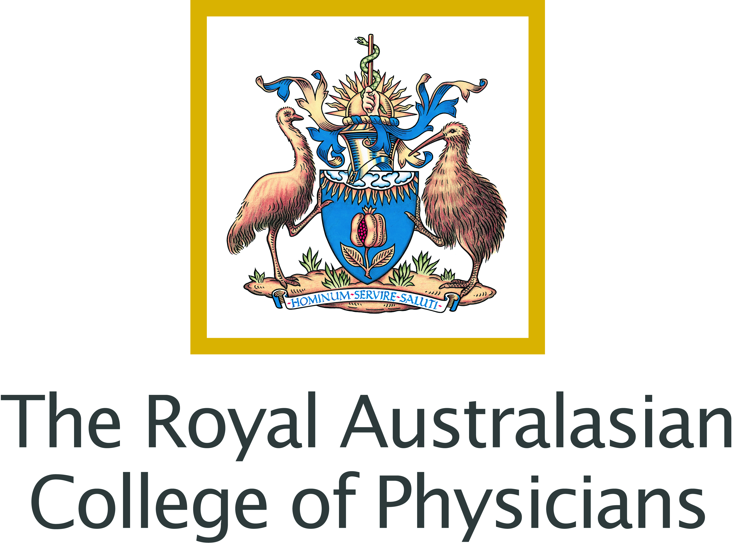

THE AUSTRALIAN HUMAN RIGHTS COMMISSION’S INQUIRY INTO THE TREATMENT OF INDIVIDUALS SUSPECTED OF PEOPLE SMUGGLING OFFENSES WHO SAY THEY ARE CHILDREN.

Submission by the Royal Australasian College of Physicians

INTRODUCTION.
The Royal Australasian College of Physicians (RACP) welcomes the opportunity to provide input into the Human Rights Commission’s inquiry into the treatment of individuals suspected of people smuggling offenses who say they are children. According to the United Nations Children’s Fund (UNICEF) only half of children under five years of age in the developing world have their births registered. Along with other factors such as loss of documents, this leaves many vulnerable to being wrongly identified as an adult and at risk of losing the protections that may be afforded to them as children under the United Nations Convention on the Rights of the Child (UNCRC), to which Australia is a signatory.
The RACP understands that while there is no scientifically accurate method of determining age that is absolute, there is still a need for some form of age assessment in the criminal justice system so that children are not trialed and incarcerated as adults. While the RACP appreciates the challenge of the Australian Government in trying to ensure that adults are not able to manipulate the system and fraudulently be treated as children, there have already been a number of well publicised cases of minors who have been be wrongfully incarcerated in Australian adult gaols.
It should also be recognised that age assessment procedures should only be undertaken as a measure of last resort where there are grounds for serious doubt. Other approaches such as interviews and attempts to access documentation should be performed initially.
CURRENT METHODS OF AGE-DETERMINATION.
Efforts have been made by the Australian Government to broaden age-determination methods beyond the Gruelich and Pyle method (GP method) for age determination. This method evaluates the bone age of children by x-raying the left hand wrist. It is understood that the Attorney-General’s Department is now considering the approach outlined in the Guidelines for Age Estimation in Living Individuals in Criminal Proceedings which includes dental x-rays, the development of focused interviews to supplement x-rays as well as taking early steps to seek documented evidence of age. However, there is still too much reliance on the GP method, which reflects the skeletal maturity not the chronological age, and this method is not supported by the RACP .

The GP method is not considered reliable and has not been validated for the purpose of determining age. The GP method was based on white middle-class Americans born in the 1930s and does not take into account factors prevalent in developing countries which include malnutrition and race. In the case of Asian boys in late childhood and adolescence its reliability as an age assessment tool is even further diminished. This is clearly a problem for assessment of individuals suspected of people smuggling offences who come from impoverished parts of Indonesia or other parts of the world.
There is also insufficient evidence to conclude that dental x-rays are accurate. As they only provide an indication of age the RACP does not support their use as either a supplementary or alternative tool of assessment.
An additional concern is informed consent. While it is understood that in Australia consent is sought from people who undergo x-rays to determine whether they are a child in the case of people smuggling, it is not clear what level of consent is gained. Gaining informed consent is a complex issue for children and for non-English speaking persons. For medical procedures, informed consent means that the person undergoing the procedure (and/ or their guardian) fully understands the procedure and its risks and consequences, as well as the risks associated with refusing tests. For children this often requires a parent or guardian who has the ability to understand the procedure. Many of these persons are not accompanied by their parents. Additionally, for those whose first language is not English, it is important that qualified interpreters are present to ensure that the procedure and the consequences are understood. If such procedures are to continue, then the RACP recommends that consent processes are clarified and reviewed if necessary.
Using x-rays to determine age is even more problematic when applied to individuals suspected of people smuggling offences who are from impoverished parts of the world. It may therefore increase the risk of some of the world’s most vulnerable children being wrongly trialled and incarcerated as adults. RACP does not support the use of x-rays for non-therapeutic reasons, including for the purpose of determining age, and is concerned about informed consent in these circumstances.
DEVELOPING ALTERNATIVE APPROACHES.
The RACP acknowledges that there is currently no accurate means of determining age of people who say they are children. However, there is room to investigate alternatives to the methods currently used in Australia. The RACP suggests investigating comprehensive assessments which may include psychological, cognitive, developmental and cultural factors, as well as comprehensive efforts to source accurate documentation of age where it exists. For example, the United Nations Guidelines for Unaccompanied Children Seeking Asylum includes an assessment of psychological maturity, as well as physical appearance, in determining the age of the person. UNICEF has reviewed age assessment practices and literature and this may be a basis for the discussion on alternatives, as well as the Separated Children in Europe Program which has recently developed criteria for age assessment within its Statement of Good Practice’.
In reviewing and developing more comprehensive assessment processes, a multidisciplinary approach is needed. A starting point for developing an alternative approach to age determination would be to invite a range of professional disciplines, such as paediatricians, social workers, psychologists and so forth, to work with government to explore and develop comprehensive and balanced assessment processes based on best evidence and international guidelines.
In the meantime, the Government should ensure that individuals claiming to be minors are not continued to be incarcerated in adult facilities. Such individuals should also be treated in accordance with the UNCRC which provides that children be detained as a measure of last resort and for the shortest appropriate period of time and, if accused of breaking the law, have the matter resolved in a way that takes into account their age and situation.

The RACP trains, educates and advocates on behalf of more than 13 500 physicians across Australia and New Zealand. The RACP represents more than 25 medical specialties including paediatrics and child health, and supports paediatricians in their practice with children.
Smith, T. and Brownlees, L. Age assessment practices: A literature review and annotated bibliography, United Children’s Fund (UNICEF), April 2011.
Office of the United Nations High Commissioner for Human Rights, Geneva. Convention on the Rights of the Child. September 1990.
Schmeling A, Kaatsch H-J, Marré B, Reisinger W, Riepert T, Ritz-Timme S, Rösing FW, Rötzscher K, Geserick G Guidelines for Age Estimation in Living Individuals in Criminal Proceedings, September 2000.
Smith, T. and Brownlees, L. Age assessment practices: A literature review and annotated bibliography, United Children’s Fund (UNICEF), April 2011, p 13.
Smith, T. and Brownlees, L. Age assessment practices: A literature review and annotated bibliography, United Children’s Fund (UNICEF), April 2011, p 13.
Smith, T. and Brownlees, L. Age assessment practices: A literature review and annotated bibliography, United Children’s Fund (UNICEF), April 2011.
Office of the United Nations High Commissioner for Refugees Geneva, Guidelines on Policies and Procedures in Dealing with Unaccompanied Children Seeking Asylum, February 1997.
Smith, T. and Brownlees, L. Age assessment practices: A literature review and annotated bibliography, United Children’s Fund (UNICEF), April 2011.
Separated Children In Europe Program Thematic Group on Age Assessment, Review of current laws, policies and practices relating to age assessment in sixteen European Countries, May 2011.
? Office of the United Nations High Commissioner for Human Rights, Geneva. Convention on the Rights of the Child. September 1990, Articles 37 & 40.

